1. Sources Code

Latihan1.php🡪controller

Latihan2.php🡪controller

model1.php🡪model

view_Latihan2.php🡪view

2. URL

<http://localhost/pustaka_ajeng/index.php/Latihan1/Penjumlahan/5/7>

<http://localhost/pustaka_ajeng/index.php/Latihan2/Penjumlahan/10/15>

3. Capture Output Program

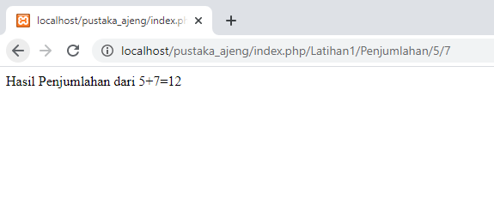 Latihan1

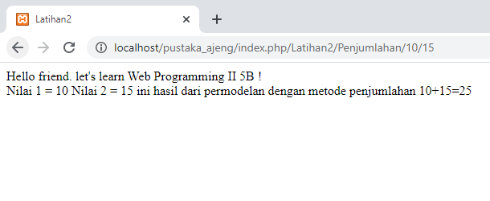 Latihan2